**June 2021**

**Product Update**

**Montana Alcoholic Beverage Control Division**

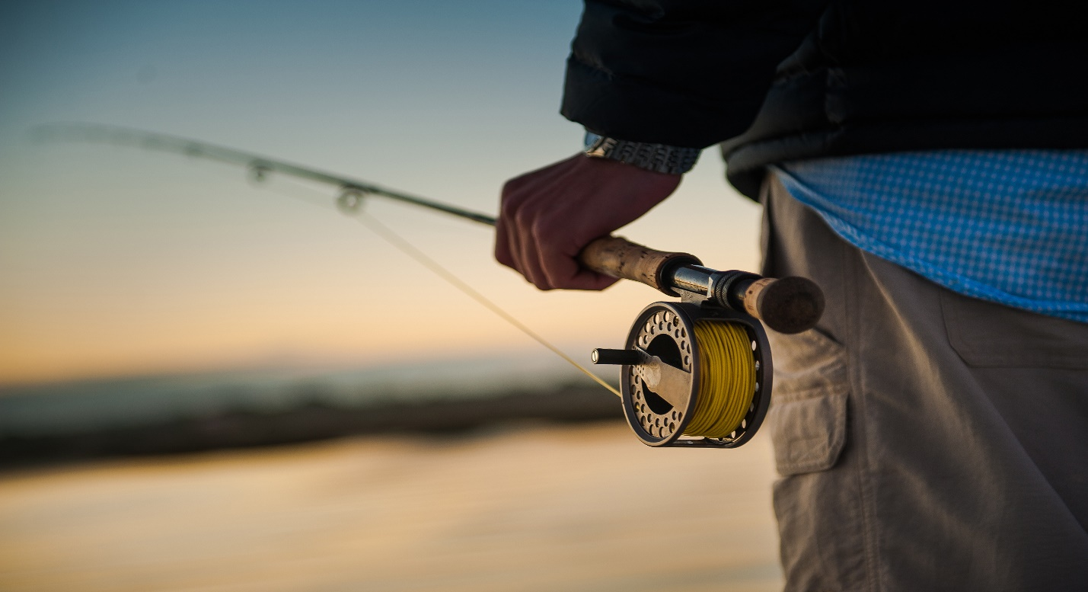

**Agent News**

**\*Crown Royal Salted Caramel 110-010784-75 is discontinued.**

**\*Hpnotiq Holiday VAP w/2 Trendy Rock Glasses 015-004150-75 is being cancelled by the supplier, so we will not be receiving it to fill the orders for stores that requested it on the Holiday 2021 orders.**

**IN THIS ISSUE**

* Agent News
* Product Update
* Order Processing Calendar
* Contact Information
* Help Hints

**Product Update**

|  |  |  |  |
| --- | --- | --- | --- |
| **PRICE CHANGES** | | | |
| **PRODUCT NAME** | **NABCA** | **PRICE (was)** | **PRICE (now)** |
| **44 DEGREES NORTH IDAHO POTATO VODKA** | **280-036207-75** | **$24.00** | **$26.15** |
| **STILLBROOK OLD STYLE 80 PF** | **151-021567-10** | **$10.45** | **$10.85** |
| **FREELAND SPIRITS GIN** | **225-030090-75** | **$31.10** | **$25.90** |
| **MELETTI CIOCCOLATO LIQUEUR (ITALY)** | **435-065939-75** | **$41.55** | **$23.40** |
| **WESTERN SON PEACH VODKA** | **290-039654-75** | **$15.20** | **$13.45** |
| **WESTERN SON WATERMELON VODKA** | **290-039707-75** | **$15.20** | **$13.45** |
| **WESTERN SON ORIGINAL VODKA** | **280-038507-75** | **$14.95** | **$13.45** |
| **WESTERN SON BLUEBERRY VODKA** | **290-039824-75** | **$15.20** | **$13.45** |
| **WESTERN SON CUCUMBER VODKA** | **290-039826-75** | **$15.20** | **$13.45** |
| **WESTERN SON GRAPEFRUIT VODKA** | **290-039841-75** | **$15.20** | **$13.45** |
| **WESTERN SON LIME VODKA** | **290-039651-75** | **$15.20** | **$13.45** |
| **WESTERN SON LEMON FLAVORED VODKA** | **290-039353-75** | **$15.20** | **$13.45** |
| **WILD ROOTS APPLE CINNAMON FLV VODKA** | **290-039620-75** | **$11.36** | **$20.10** |
| **ROTHMAN & WINTER CREME DE VIOLETTE** | **410-066240-75** | **$22.90** | **$23.50** |
| **ROTHMAN & WINTER ORCHARD APRICOT LIQ** | **475-066242-75** | **$22.90** | **$23.50** |
| **BOONE & CROCKETT CLUB AMER BLENDED WHSK** | **160-022936-75** | **$28.10** | **$26.85** |
| **BOONE & CROCKETT CLUB STRAIGHT RYE WHSKY** | **181-026809-75** | **$38.50** | **$36.00** |
| **BOONE & CROCKETT CLUB STRGHT BOURBON** | **199-026811-75** | **$36.90** | **$34.40** |
| **STOLI ELIT VODKA** | **255-034729-75** | **$44.85** | **$39.95** |
| **STOLICHNAYA ELIT IMPORTED VODKA** | **255-034827-17** | **$82.25** | **$79.95** |
| **VILLA ONE SILVER TEQUILA** | **498-088464-75** | **$39.95** | **$40.00** |
| **VILLA ONE REPOSADO TEQUILA** | **499-088463-75** | **$44.95** | **$45.00** |
| **VILLA ONE ANEJO TEQUILA** | **499-088462-75** | **$54.95** | **$55.00** |
| **JACOPO POLI DI MOSCATO GRAPPA** | **355-051274-37** | **$85.50** | **$59.05** |
| **MATTINGLY & MOORE BLENDED WHISKEY** | **152-019632-10** | **$8.95** | **$8.25** |
| **CLUB LIME MARGARITA** | **398-058490-20** | **$0.76** | **$1.50** |
| **CLUB LONG ISLAND ICED TEA** | **398-060033-20** | **$0.76** | **$1.50** |
| **GEORGE REMUS RESERVE STRGHT BRBN** | **151-018412-75** | **$40.15** | **$31.25** |
|  |  |  |  |

|  |  |  |  |
| --- | --- | --- | --- |
| **NEW PRODUCTS** | | | |
| **PRODUCT NAME** | **NABCA** | **PACK** | **PRICE** |
| **YAMOTO TAKEDA SHINGEN JAPANESE WHISKY** | **130-016103-75** | **6** | **$99.90** |
| **BASIL HAYDEN TOAST KENTUCKY SBW** | **151-016685-75** | **6** | **$43.40** |
| **DIFIANT RYE (BLUE RIDGE DIST)** | **181-026999-75** | **6** | **$45.70** |
| **CLUB MANHATTAN (CAN)** | **398-060053-20** | **24** | **$1.50** |
| **THE CLUB COCKTAILS MOSCOW MULE** | **398-063870-20** | **24** | **$1.50** |
| **EL NIVEL REPOSADO SMALL BATCH ORGANIC TQ** | **499-088954-75** | **6** | **$37.20** |
| **EL NIVEL BLANCO SMALL BATCH ORGANIC TEQ** | **498-087599-75** | **6** | **$30.15** |
| **HIGH NOON SUN SIPS/8-PK:PN/W/MG/PF 355ML** | **030-101468-35** | **24** | **$2.55** |
| **BROOKLYN HANDCRAFTED SMALL BATCH GIN** | **225-029550-75** | **6** | **$35.95** |
| **DRY HILLS FOUR GRAIN STRAIGHT BOURBON\*** | **151-017662-75** | **6** | **$37.50** |
| **FORD'S LONDON DRY DISTILLED GIN** | **200-028485-75** | **6** | **$23.45** |
| **FULL CURL GIN** | **225-990671-75** | **6** | **$32.70** |
| **FULL CURL VODKA** | **280-990672-75** | **6** | **$27.55** |
| **OWEN'S MASH BILL 3 SPIRIT DS RYE/CRN/BRY\*** | **401-076427-75** | **6** | **$29.50** |
| **ROSALUNA MEZCAL ARTESANAL JOVEN ESPADIN** | **498-087875-75** | **6** | **$32.75** |
| **TANTEO BLANCO TEQUILA** | **498-088395-75** | **6** | **$35.95** |
| **TANTEO CHIPOTLE INFUSED TEQUILA** | **449-067153-75** | **6** | **$35.95** |
| **TANTEO HABANERO INFUSED TEQUILA** | **449-067174-75** | **6** | **$35.95** |
| **THE MACALLAN DOUBLE CASK 12Y HIGHLAND SM** | **100-005585-05** | **120** | **$6.00** |
| **THE MACALLAN DOUBLE CASK 12Y HIGHLAND SM** | **100-005587-17** | **6** | **$132.40** |
| **UMIKI (JAPANESE OCEAN FUSED WHISKY)** | **401-067219-75** | **12** | **$45.05** |
| **XICARU SILVER MEZCAL** | **498-088730-75** | **6** | **$31.95** |
| **YAMOTO TAKEDA SHINGEN JAPANESE WHISKY** | **130-016103-75** | **6** | **$99.90** |
|  |  |  |  |

**\* = In State Distillery.**

|  |  |
| --- | --- |
| **DISCONTINUED** | |
| **PRODUCT NAME** | **NABCA** |
| **COLD RIVER VODKA** | **280-035602-75** |
| **COLD RIVER GIN** | **225-029830-75** |
| **COLD RIVER BLUEBERRY VODKA** | **290-041156-75** |
| **BOOZIE CRANBERRY RTD 6** | **398-057211-35** |
| **CIROC SUMMER CITRUS FL VOKDA** | **403-064389-75** |
| **KNOB CREEK BOURBON 100 PF** | **151-019221-05** |
| **FIGHTING COCK BOURBON** | **151-018271-05** |
| **SAM HOUSTON 14YR KENTUCKY STRT BRBN** | **165-021382-75** |
| **SKYY BARCRAFT WATERMELON FRESCA** | **403-077100-75** |
| **CROWN ROYAL NORTHERN HARVEST RYE** | **110-010822-37** |
| **CROWN ROYAL SALTED CARAMEL** | **110-010784-75** |

**PLEASE REFER TO YOUR ORDER PROCESSING CALENDAR FOR CHANGES TO YOUR ORDER DATE TO ENSURE YOUR ORDER IS PROCESSED.**

**June & July 2021**

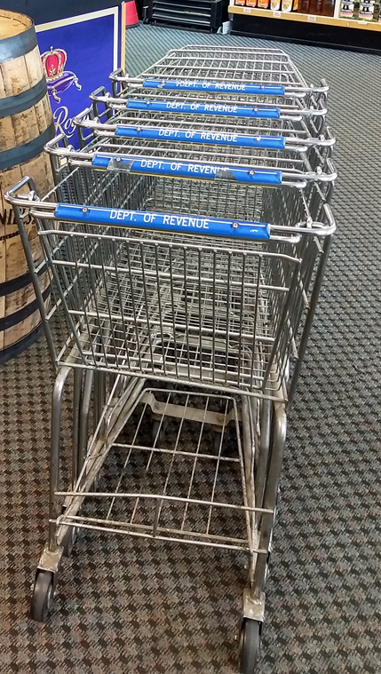

**LIQUOR DISTRIBUTION TEAM**

**LaNor Stigen**

ABCD Bureau Chief

LStigen@mt.gov

406-444-5807

**Mickey Carlson**

Agency Store Specialist

micarlson@mt.gov

406-444-0724

**Lisa Patzer**

Purchasing Agent

Lisa.Patzer@mt.gov

406-444-4003

**JAY GAUGHAN**

Auditor

[jgaughan@mt.gov](mailto:jgaughan@mt.gov)

406-444-2909

**Tanner van wyck**

Purchasing AGENT

Tanner.VanWyck@mt.gov

406-444-1232

**jana delong**

Store Order Technician

Jana.DeLong@mt.gov

406-444-2938

**ABC DIVISION**

**P.O. Box 1712**

**Helena, MT 59624**

**2517 Airport Road**

**Helena, MT 59602**

**EMAIL:**

**DORAlcoholicBeverageControl@mt.gov**

**TAP ORDERS to:**

**https://tap.dor.mt.gov/_/**

**EMAIL ORDERS to:**

**DORLiquorOrders@mt.gov**

Helpful Hint:

You get 3 unsuccessful tries to log into your TAP account before you get locked out. You must call to get unlocked.

