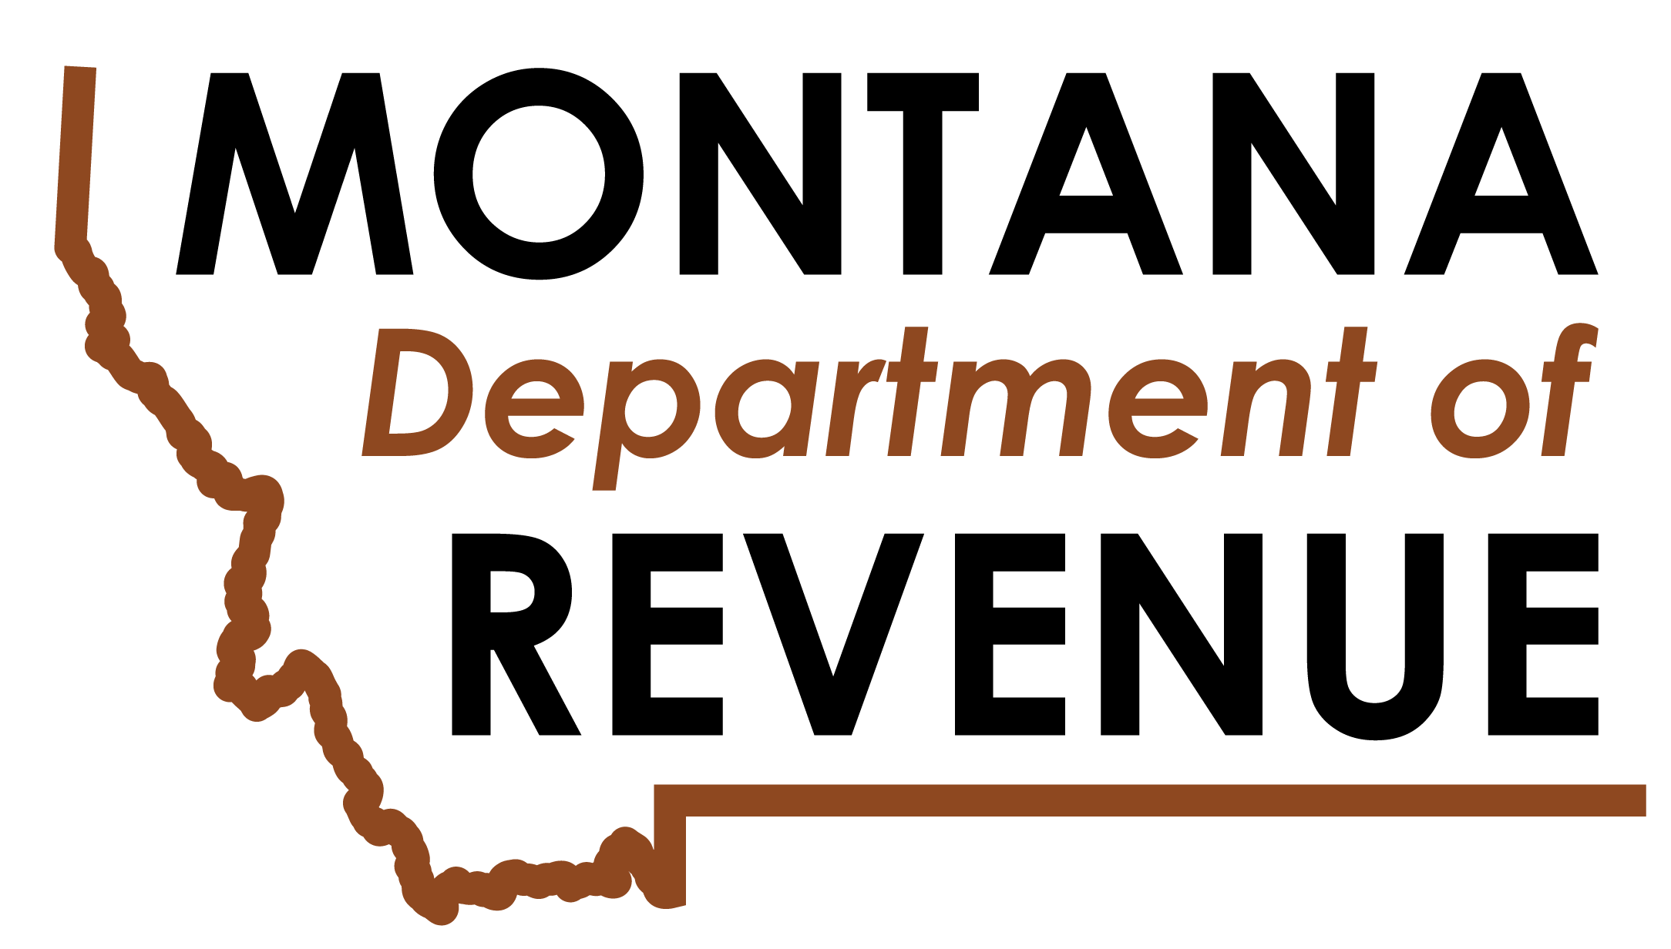

ATTENTION! Something is new on your renewal.

There is a new section on the alcoholic beverage license renewal form this year. It isn’t new to Montana law, but it is a new requirement on the renewal form. It is important you carefully read the Authorization to Disclose Tax Information section.
If you receive a paper copy of the renewal it is in Section I for a retail on-premises license type and in Section H for other license types. You must have each individual having 10 percent or more ownership in the license sign that section of the renewal page. If you run out of signature lines, please make a copy of that page of the renewal and use the copied page for additional signatures.

This is what the retail on-premises license type paper renewal section will look like:

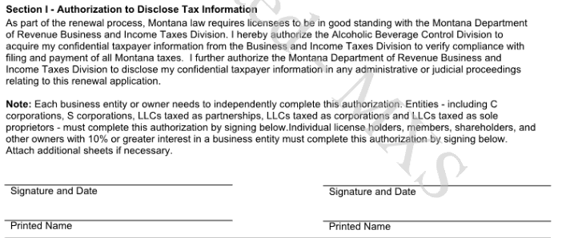

This is what the other license types paper renewal section will look like:

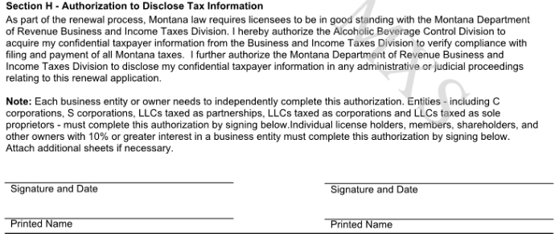

If you complete your renewal online through TransAction Portal (TAP) it is in Section 3 Business Personnel. You are required to download, fill out and attach an Alcoholic Beverage Control Division Authorization to Disclose Tax Information form to the renewal for the Entity that owns the license AND each individual having 10 percent or more ownership in the license.

This is what the online renewal section will look like:

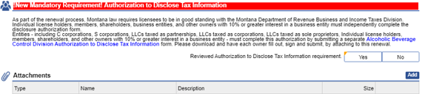

Please note: If the renewal paperwork is not complete you will NOT receive your new license.
See our new tutorials on how to complete your renewal online here.

MTRevenue.gov  (406) 444-6900  TDD Montana Relay 711

